24.6: (a) 12.0 V since the plates remain charged.
(b) (i) 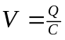
Q does not change since the plates are disconnected from the battery.
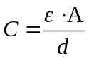
If d is doubled, 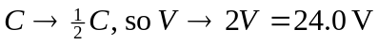
(ii) which means that
